Moving fish
Activity 1
Students will get in pairs. Teacher will hand out a map and a fish to students. Each fish has a place to go inside its mouth. Students will create a conversation where they give instructions for the fish to arrive to its destination. After that, each pair will present the conversation and the directions they gave. The teacher will evaluate if the directions were correct (if they arrive to the place).
Grammar--- imperatives/ prepositions
Vocabulary--- giving directions/ places
Skills--- writing/ listening/ speaking

Activity 2
Students will create a fish with three different colors. The teacher will give instructions about each part of the fish, creating her own fish at the same time of the students. Then, students will present their own fish by describing the parts of the fish and the colors they use for it.
Grammar--- verb to be
Vocabulary--- body parts and colors
Skills--- speaking/ listening
Pictures:
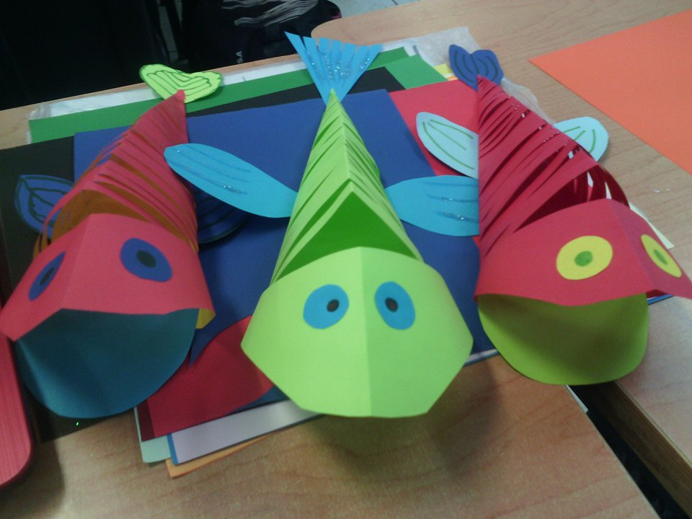

Names:
- Brenda Elizabeth López Gómez
- Michelle Alondra Delgado Romo
- Diana Rosalba Pérez González

