HOW IS THE WEATHER?
NAME: __________________________________________ DATE: ________________

Find the vocabulary about weather that corresponds with each image below.
Q | D | T | Y | H | V | N | O | X | Z | Y | N | M | P
L | Q | A | S | S | U | N | N | Y | B | F | Z | J | Ñ
K | M | G | L | D | R | B | E | U | T | C | V | B | G
G | H | Y | E | S | X | L | P | O | I | J | N | V | H
L | E | R | Q | T | Y | W | U | F | C | K | D | U | L
Y | R | A | A | R | U | D | N | W | V | J | S | H | N
T | G | I | X | E | H | C | E | B | I | A | E | O | U
I | U | N | Z | W | V | L | W | Y | X | N | Q | P | S
U | O | Y | V | R | B | Ñ | X | E | Z | A | D | L | D
W | I | E | B | Y | V | P | R | W | J | V | T | Y | F
M | S | R | W | Y | L | O | Y | Q | Ñ | U | O | M | P
X | A | O | N | U | Ñ | Q | U | R | P | O | Ñ | B | B
Z | N | U | U | I | C | L | O | U | D | Y | N | W | M
S | N | V | B | R | E | X | C | L | U | D | I | N | R

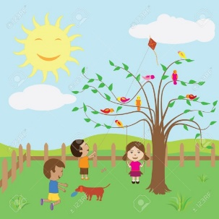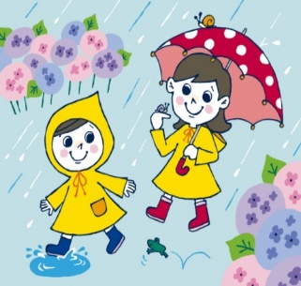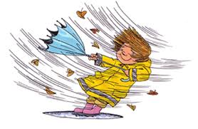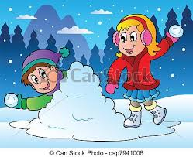
MATERIAL
Images (one image in a sheet)

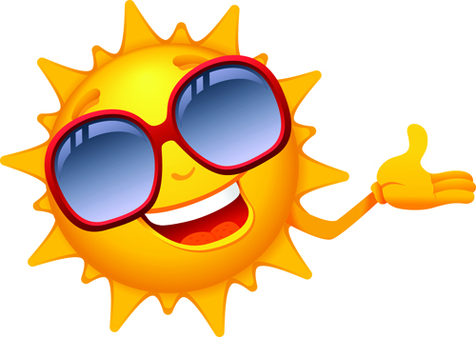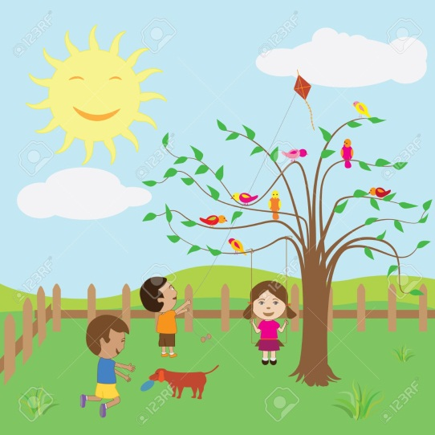

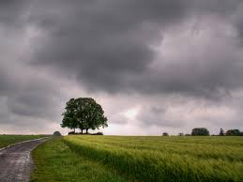
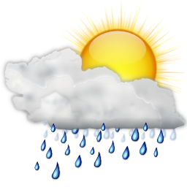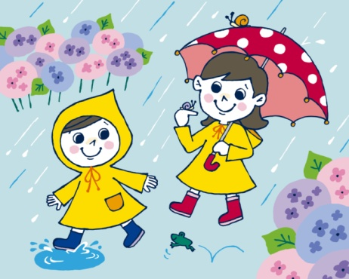

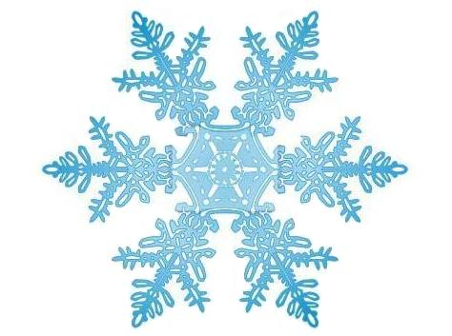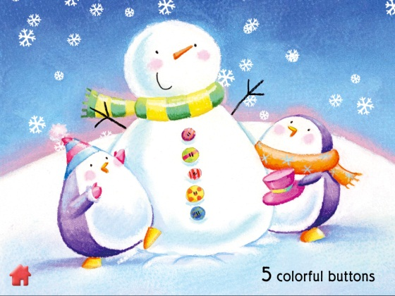

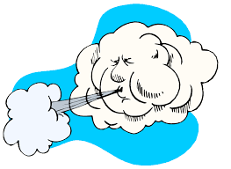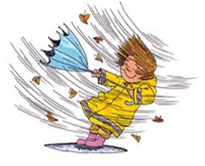
WEATHER
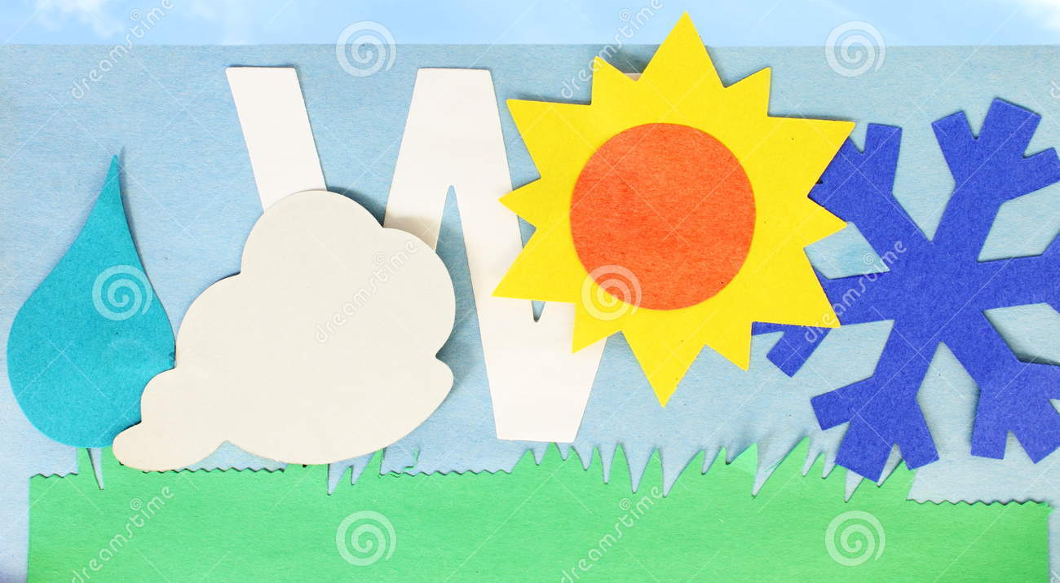
WIND
WINDY
RAIN
RAINY
SUN
SUNNY
CLOUD

CLOUDY
SNOW

SNOWY

(One Word in a sheet)

Little papers
WIND | WINDY
SNOW | SNOWY 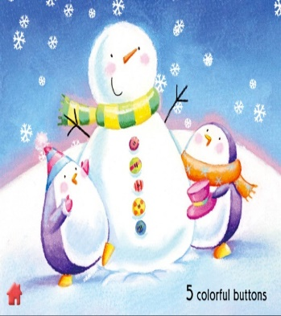
SUN | SUNNY 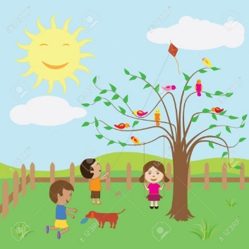
RAIN | RAINY 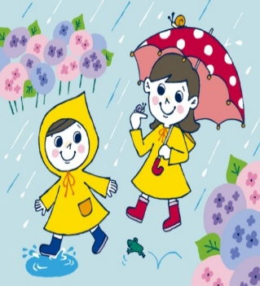
CLOUD | CLOUDY

