January/24/2017
First assignment

Dice
(Made of one carton box, newspaper, glue, tape, and color sheets)

Objective
The objective of this tool is to teach different topics, also to review topics that students have seen during the course.
Skills
The skills that students can practice with the dice are not only speaking, listening, reading, and writing, but also spelling, pronunciation, and grammar because it depends on what does the teacher wants to review or to teach and also depend on the topics.
Topic
It depends on the teacher. The topics can be very varied.
How would you use it?
The students only have to throw it and perform the activity that is establish on the top face of the dice.
Ss' profile
The teacher can choose the topics, which means that the students profile could be varied. It could be used from basic levels to advanced ones.
Two other uses
- The dice could be also used to play a board game such as the goose game, so depending on the number of points each question has, the students can go ahead up to the end.
- Also, it could be used to check reading comprehension pasting questions that are related with the reading on the faces of the dice. And those questions will depend on the teacher too.

Photos
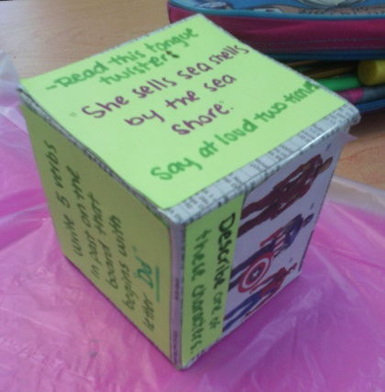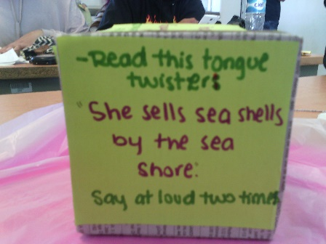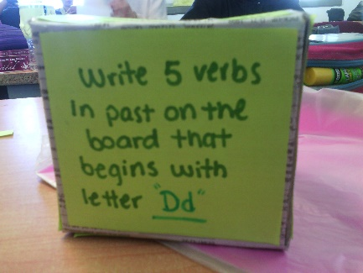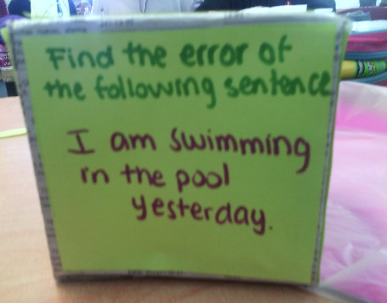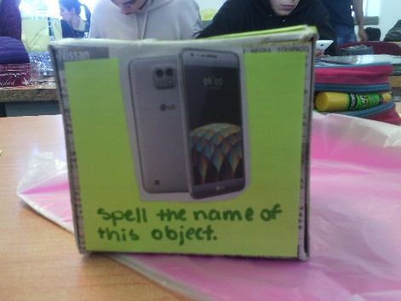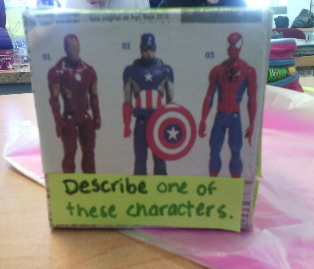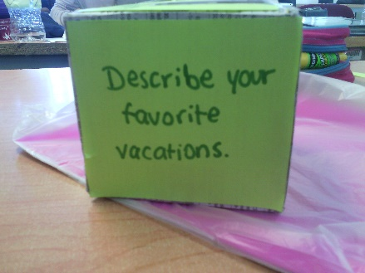

Made by
Diana Rosalba Pérez González
Brenda Elizabeth López Gómez

