PAPER
Cards divided into four categories by color. Each of the cards contains a word related to this category. The cards are kept inside a paper box.
Uses:
-Ice-breaker (Speaking activity)
-Making groups/teams (Each team has to present a grammar topic)
-Guessing game (Vocabulary)
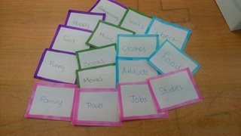
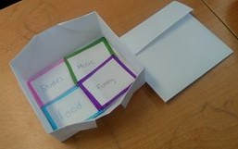
-Spelling bee (Vocabulary and the alphabet)

COMPUTER
A PowerPoint slide that has the numbers form one to nine in a 3x3 chart.
Uses:
- Use them as if they were flashcards (Practice numbers)
-Make study groups (Review the topics of a unit)
-Random activity: each number represents an activity. The students choose one of the numbers, and this is the activity they will have to do (Idioms)

